**Import and Export (csv, json, tsv):**

# **Name : Rajkumar B L**

# **Reg.No : 2047120**

# **Course : MCS NoSQL (LAB 04)**

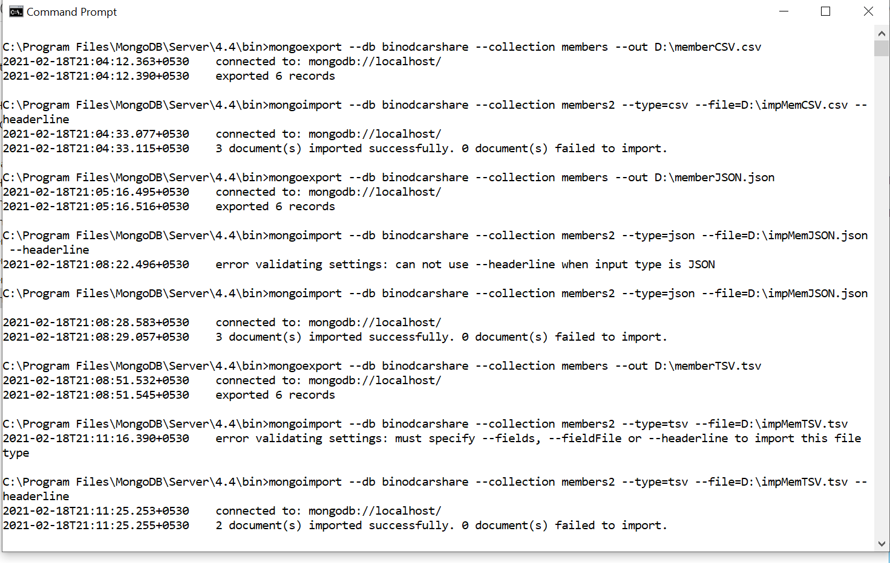

**Files**

